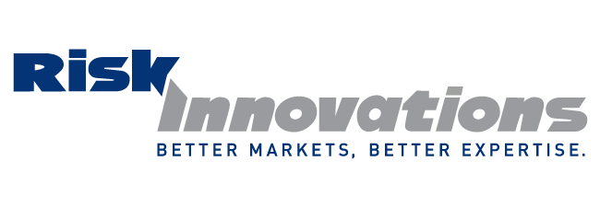

REMINDER: Ethics and General CE Credits can be used for either L/H or P/C credit
DAY 1 MORNING Wednesday, June 8 AFTERNOON

10:00 am - Noon Workers Comp
Experience Modification 2PC
The experience modification is a comparison of how a business’ losses compare historically to their peers and has an important impact on the price of their future workers compensation insurance.
You will take away:
- The fundamentals of the experience modification
- Basic risk management theory
- How the experience modification impacts the customer
- How the experience modification is used by insurance carriers
- How the experience modification can impact real life cost scenarios

Noon Lunch Break courtesy of

1:00 – 4:00 pm Ethics in Workers Comp 3ETH
Given that workers compensation is a statutory coverage, the purchase of a work comp policy goes beyond simply providing coverage for workplace injuries; it also requires compliance with state or federal employment laws.
You will take away:
- The ethical role of the policy holder, insured and insurance carrier in regard to the WC policy
- The role of ethics in claims reporting and handling
- Ethical implications in underwriting applications and decisions
- Ethical considerations in premium

5:00 pm DINNER on Main Street

DAY 2 MORNING Thursday, June 9 AFTERNOON

8:00 - 10:00 am Advanced Lawsuit Protection, Tax Reduction,
and Estate Planning Strategies 2GEN
This lecture provides insurance agents solutions to three major problems: lawsuits, taxes, and probate.
Attendees will learn:
- How to make yourself unattractive to a plaintiff attorney so they will not
pursue a lawsuit against you.
- Five tax reduction strategies often missed by professionals and their advisors.
- Tools you can use to pass assets to your heirs tax free.

10:00 am – Noon Social Security Benefits 2LH
New Guidelines You Need To Know
This course will help you understand when and why to draw Social Security benefits and not to overlook this important asset when talking with your clients. Retirement benefit planning has changed greatly in the past six months; don’t pass up this chance to bring yourself up-to-date on the new guidelines that just became effective May 1st.

OFFICIAL NOTICE: PIA ANNUAL BUSINESS MEETING & LUNCH NOON Thursday - June 9, 2016 1GEN

1:00 - 3:00 pm New Technology – New Exposures – New
Challenges 2PC
This two hour class discusses exposures related to Uber, AirBNB, Drones, Going Green and more. Bring your knowledge up to date, learn the shortcomings of existing policies and be able to offer coverage solutions for your customers.

3:00 – 5:00 pm Ethics: Everything Has Changed 2ETH
Working with new technology and new ways of thinking creates an ethical dilemma and moral challenge. How will our role as agents evolve? The participant will learn a simple five step process to apply to ethical problem solving.

5:30 pm DINNER at DAIMARU Japanese Steakhouse

DAY 3 MORNING Friday, June 10

8:30 am – 12:30 pm Insuring Toys: We Have Them – Our Customers Have Them 4PC

Motorcycles, ATVs, Campers, Golf Carts. This class explores the exposures and then searches for coverage solutions under the Homeowners and Personal Auto Policies, as well as recreational vehicle policies. Avoid the pitfalls of writing this business by attending this class. Over



We’re serving up a smorgasbord of FREE Continuing Education!
JUNE 8-10, 2016
Salina, KS

Wednesday, June 8 Jim Rose, Director of Business Development, BerkleyNet

Thursday, June 9 Larry Oxenham, American Society for Asset Protection
John Rupright, ProducersXL
Mary LaPorte, CPCU, CIC, LIC, CPIA, LaPorte Consulting LLC Up to
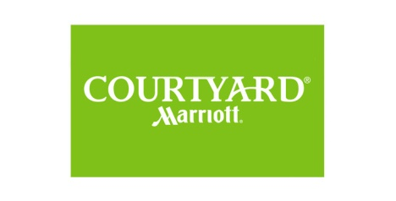
Friday, June 10 Mary LaPorte, CPCU, CIC, LIC, CPIA, LaPorte Consulting LLC 18 hrs


Summer School is made possible by our PIA PARTNERS IN ACTION

Progressive Insurance
Risk Innovations
Specialty Insurance Managers
Upland Mutual Insurance
Utica National Insurance
Bohrer-Croxdale & McAdoo
Chris-Leef General Agency
Columbia Insurance Group
Farmers Alliance
Farmers Mutual Insurance Company
Graham-Rogers
Imperial PFS
Markel FirstComp
M. J. Kelly Company
Bremen Farmers’ Mutual Insurance
Buckeye Insurance Group
Kansas Mutual Insurance Company

785.309.1300
When making reservations please mention “KS PIA”
3020 Riffel Drive in Salina
Room block expires May 27th

Event Attire: Summer Casual - this is an easy, relaxed three days. Jeans, shorts, sandals are ok!

REGISTRATION FORM MEMBERS: FREE (includes lunch both days) Non-Members: $15 per credit hour (lunch free w/reg)
FREE MEMBER REGISTRATION
Fax: 785-232-0272
Online: www.kansaspia.org
E-mail: pia@pia.kscoxmail.com

NON-MEMBER REGISTRATION
Check to: PIA, 216 SW 7th Topeka KS 66603
MC/VISA: call PIA at 800-836-7387

REGISTRATION DEADLINE: JUNE 3, 2016
?/Questions: E-mail: pia@pia.kscoxmail.com
Phone: 785-232-4143 or 800-836-7387

A confirmation will be sent once registration is received.

Please indicate number attending

WEDNESDAY/JUNE 8
WC Experience Modification 10:00 am - Noon
Lunch Noon - 1:00 pm
Ethics in WC 1:00 - 4:00 pm

THURSDAY/JUNE 9
Lawsuit and Tax Protection 8:00 - 10:00 am
Social Security 10:00 am - Noon
Lunch/Business Meeting Noon - 1:00 pm
New Technology/Challenges 1:00 - 3:00 pm
Ethics 3:00 - 5:00 pm

FRIDAY/JUNE 10
Recreational Vehicles 8:30 - 12:30 am
Name(s)

NPN#
NPN#
Agency/Co
City
Phone
Fax

E-mail

