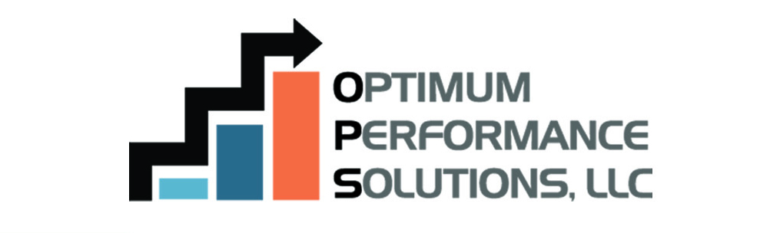
Members receive a FREE initial consultation and a discount off of a broad range of agency management consulting services.

Optimum Performance Solutions’ professional staff will work hard to design a plan to satisfy your specific needs and maximize your profitability, value, effectiveness and efficiency. Their consulting services include:
- Strategic Planning
- Staff Compensation
- Agency Valuation
- Mergers & Acquisition services
- Perpetuation Planning
- Marketing & Retention consultation
- Profitability Analysis & recommendations
- Workflow Analysis Training (Including Sales & Service training for staff)
- General Consulting
- Expert Witness Testimony
For more information please visit their website at www.optperform.com or contact Jon Persky or Becky Lathrop and let them know you are a member of the Professional Insurance Agents.
CONTACTS: Jon Persky: (813) 835-7337 or jon@optperform.com Becky Lathrop: (516) 373-0560 or becky@optperform.com

